DataDiVR User Manual

1. Controllers

* Select a node (at the tip of virtual index finger)

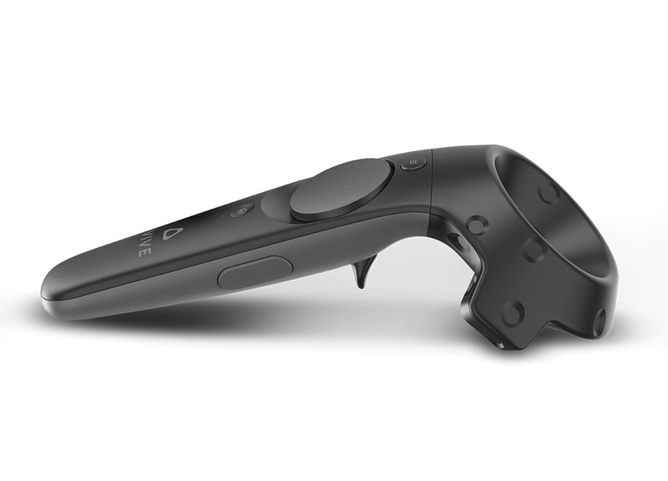

* Move(right) or rotate(left)

1. Files

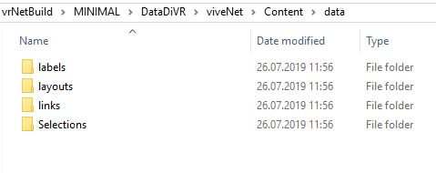

Inside the DataDiVR folder navigate to the data folder.

Put the .csv’s with your networks in here. [See specs for formats](https://github.com/menchelab/datadivr-demo)

1. User Interface

The main user interface appears if you twist your right hand so that you are looking at your palm. The idea is that it resembles a clipboard. In the top row you have tabs that switch between different widgets

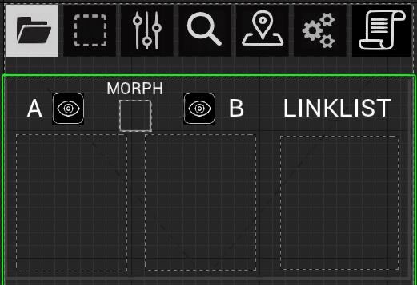

All UI elements work like the touchscreen, no controller button is needed. Buttons are triggered when you release them, similar to a smartphonekeyboard

* Load networks
* Nodelist Channel A: click to load a nodelist
* Nodelist Channel B: this is needed for the morph feature.

Attention: this displays the colors of what is loaded in

channel A

* Linklist: load a linklist. Attention: linklist must have the same name than a nodelist or contain the name of a nodelist, ex:

Nodelist = somename.csv

Linklist = somename_edges1.csv or

Linklist = somename.csv

are valid.

By now the game needs to be restarted to refresh these lists.



* Morph
* Channel indicators shows which channel is displayed
* Selection sets: load a set of nodes from .csv and highlight them

This feature is atm incomplete, buttons marked in red don’t do what they should jet ☹

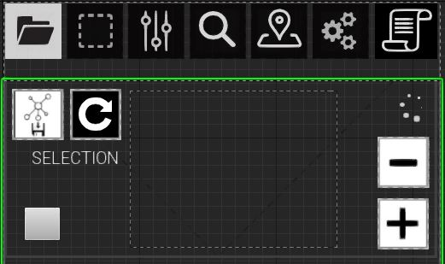

* Appearance: some sliders to tweak visual parameters of the network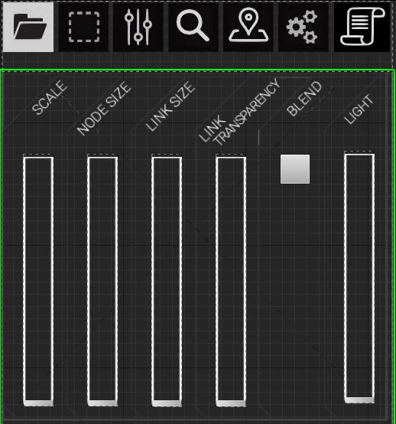
* Selection

Once you select a node an annotation spawns. it has a button that when pressed adds an entry to that list. You can click it to get back to that node quickly

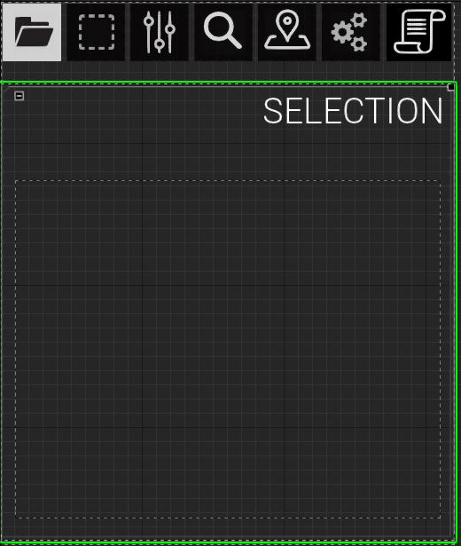

* Search brings up a keyboard in front of the user. Type the name of a node and this widget will show an auto completed list of matching nodenames (first entry in string field)

If this button is checked it will search the whole string

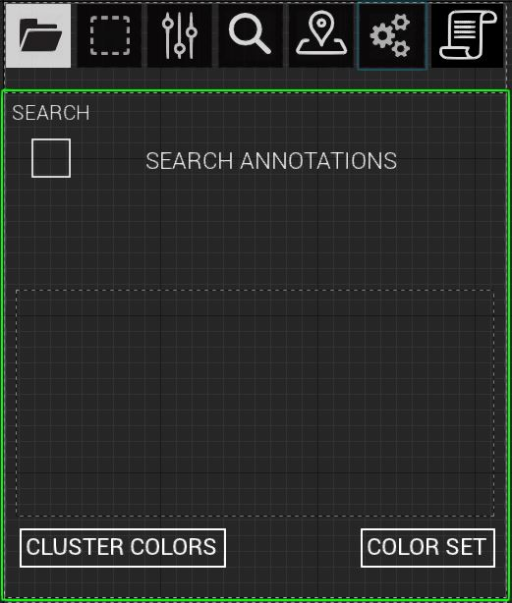

This button reverts to the colors in the nodefile

This button colors all nodes in the list

* Random Walk

First, select a node either by clicking on it or using the search widget, then press Random Walk.

Attention: there is a bug that requires you to touch the sliders

Before it works correctly ☹

